# Lab: Database Basics MySQL Queries

Problems for exercises and homework for the ["Technology Fundamentals" course @ SoftUni](https://softuni.bg/courses/technology-fundamentals).

Submit your solutions (source code) of all below described problems in the [Judge.](https://judge.softuni.bg/Contests/1342/Databases-Basics-Lab)

## Create New Database

First start **HeidiSQL**. Then write a query that will create the "softuni" database.

Queries are written in the "Query" tab:

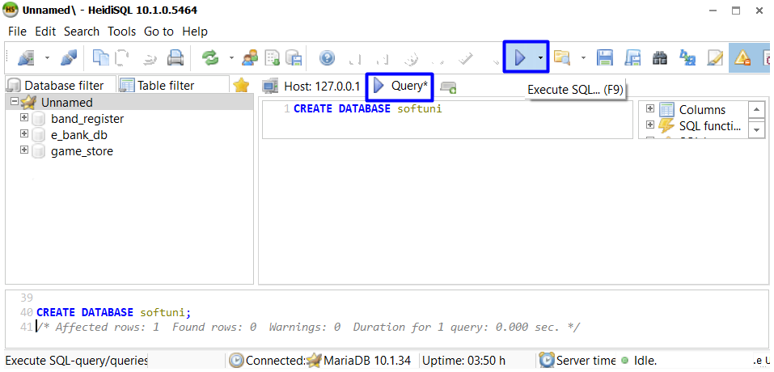

When we create database, we specify the database we want to use. This is done by using the "USE" clause:

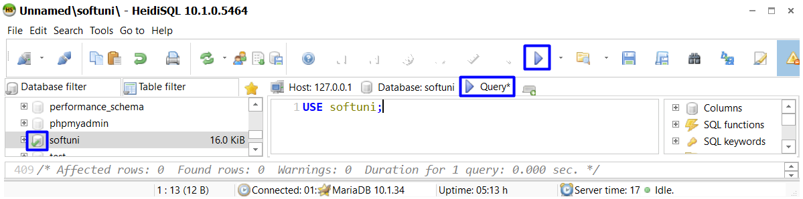

## Create Table

**Submit your solutions in JUDGE without the** "USE {database name}" **row**:

Using **HeidiSQL** in database "softuni" create table "students". You should specify five columns:

* Name: id, Datatype: INT, Autoincrement, Primary Key
* Name: first_name, Datatype: VARCHAR, Max Length: 50, Allow NULL: true
* Name: last_name, Datatype: VARCHAR, Max Length: 50, Allow NULL: true
* Name: age, Datatype: INT, Allow NULL: true
* Name grade, Datatype: DOUBLE, Allow NULL: true

## Insert Data

Insert 6 recordings in "students" table.

### Example

|  |  |  |  |  |
| --- | --- | --- | --- | --- |
| **Id** | **first_name** | **last_name** | **age** | **grade** |
| 1 | Guy | Gilbert | 15 | 4.5 |
| 2 | Kevin | Brown | 17 | 5.4 |
| 3 | Roberto | Tamburello | 19 | 6 |
| 4 | Linda | Smith | 18 | 5 |
| 5 | John | Stones | 16 | 4.25 |
| 6 | Nicole | Nelson | 17 | 5.50 |

## Find All Records

Write a query to find all records.

## Find Last Name, Age and Grade

Write a query to find last name, age and grade of each student.

|  |  |  |
| --- | --- | --- |
| **last_name** | **age** | **grade** |
| Gilbert | 15 | 4.5 |
| Brown | 17 | 5.4 |
| Tamburello | 19 | 6 |
| Smith | 18 | 5 |
| Stones | 16 | 4.25 |
| Nelson | 17 | 5.50 |

## Find First 5 Records

Write a query to find first 5 records.

|  |  |  |  |  |
| --- | --- | --- | --- | --- |
| **Id** | **first_name** | **last_name** | **age** | **grade** |
| 1 | Guy | Gilbert | 15 | 4.5 |
| 2 | Kevin | Brown | 17 | 5.4 |
| 3 | Roberto | Tamburello | 19 | 6 |
| 4 | Linda | Smith | 18 | 5 |
| 5 | John | Stones | 16 | 4.25 |

## Find first 5 Last Name and Grade

Write a query to find top 5 records. Select only last name and grade.

|  |  |
| --- | --- |
| **last_name** | **grade** |
| Gilbert | 4.5 |
| Brown | 5.4 |
| Tamburello | 6 |
| Smith | 5 |
| Stones | 4.25 |

## Truncate Table

Remove all records in "students" table.

## Drop Table

Drop table "students".

## Drop Database

Drop database "softuni".